Firebase Gmail Authentication-Angular 5

**Introduction:**

Firebase Authentication provides back-end services, and ready-made UI libraries to authenticate users to our websites. It supports authentication by using passwords, phone numbers, popular federated identity providers (e.g. Google, Facebook, Twitter, GitHub), and more.

**Procedure:**

**Step1:** Install firebase Running this command.

* npm install firebase --save

**Step2:** Adding Authentication.

* Create a Firebase app. Visit [firebase.google.com](https://firebase.google.com/) and click Sign In. Then click Go to Console.
* Once you're in your dashboard, click Add Firebase to your web app and copy the configuration settings.
* Go to *app-component* and create a new ts file and paste the configuration like this:

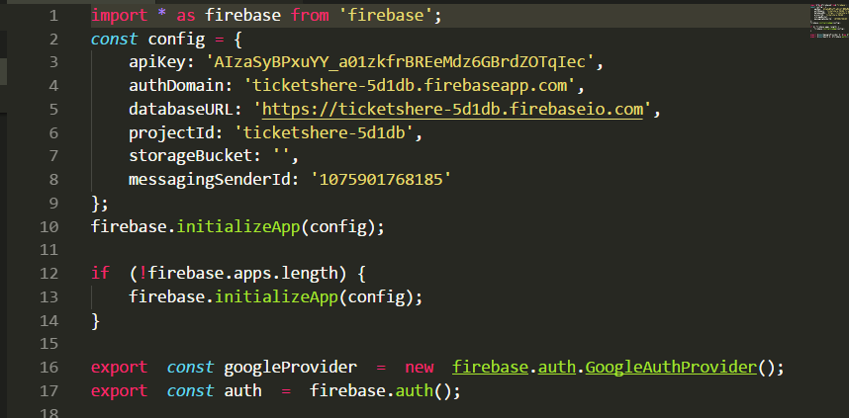

* Go to app.module.ts and import the AngularFireModule, and AngularFireAuth module if you want Auth Guard. Also, import the environment configuration. Add these to 'imports' under 'NgModule Decorator'.

**Step3:** Enabeling Google Authentication

* Google Authentication must be enbled in Your firebase Account Develop/Authentication/Sign-in methods, and enable google.

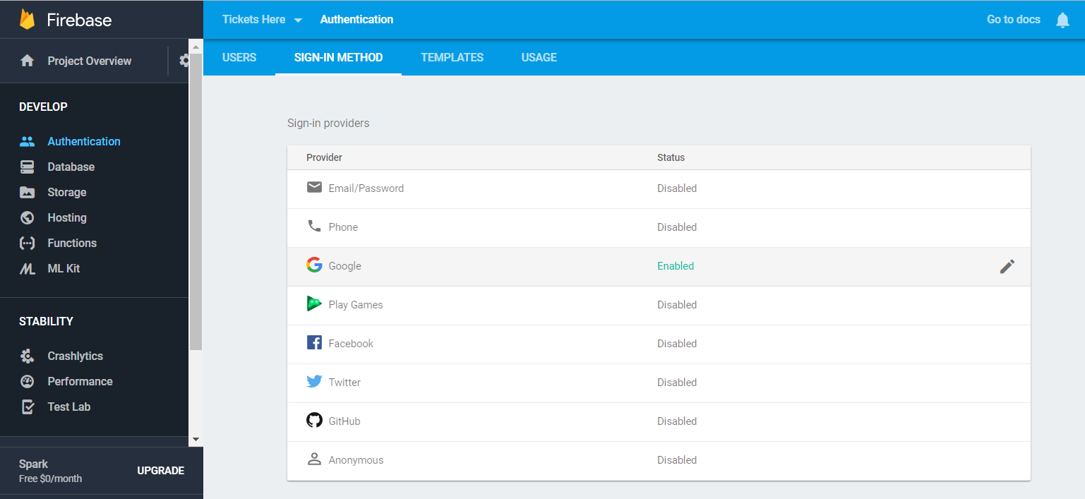

**Step4**:Getting User Details.

* Import auth, googleprovider and inject them into a component.
* auth.signInWithPopup(googleProvide) method should be triggerd on click event of social login button
* After Authenticating the user an object is returned by the above method contains whole the data of the authenticated user.

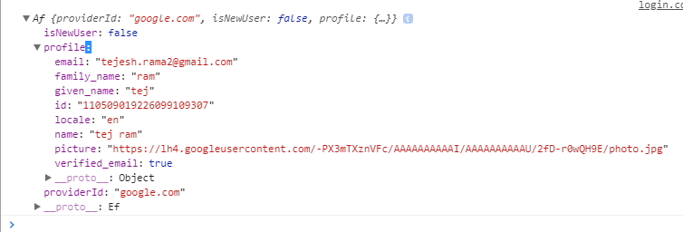

Now you can play with this data.

THANK YOU